Project Report Template

1. **INTRODUCTION**

1.1 Overview

A school management CRM (customer relationship management ) is a software tool designed to help schools and educational manage their interactions with students, parents ,teachers, and other stakeholders. With a school management CRM , you can :

Keep track of student and parent contact information , including phone numbers ,email addresses, and physical addresses

Track and analyze student performance and progress

Overall, a school management CRM helps to streamline and automate many of the administrative tasks associated with running a school, making it easier for educators to focus more on their primary goal of providing high-quality education to their students .

1.2 Purpose

* Provides good customer relationship management with schools, students and parents.
* Provides detailed information of the schools, students and parents.
* Provides teachers to focus more on there primary goals and provide high-quality education.
* Provides you all the related details of students and school like providing the mark of the students and highest score and etc..
* Provides to see the reports and progress of the students.
* Provides easy access and manage the time management.
* Provides user friendly atmosphere and it is made in very simple understanding language.
* Provides every single detailed information of the students.
* Provides very secured and safe environment while using it.

1. **Problem Definition & Design Thinking**

2.1 Empathy Map

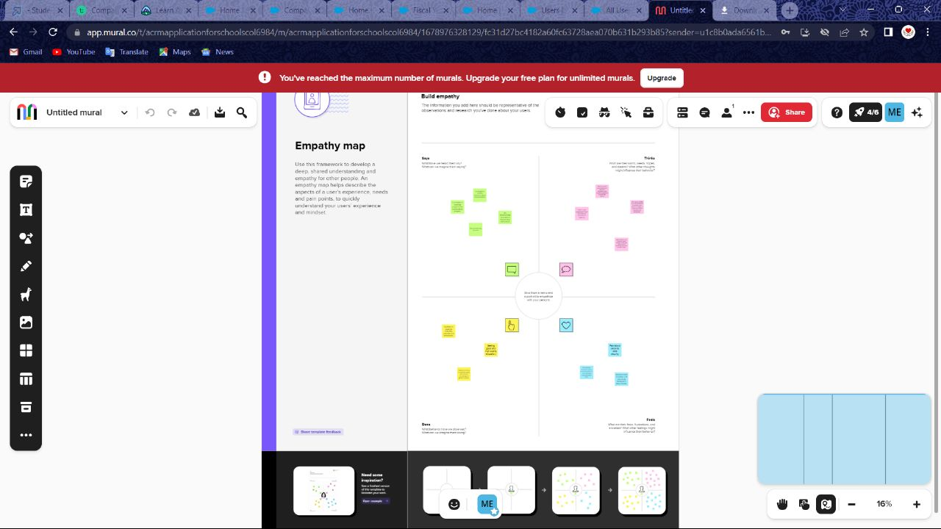

2.2 Ideation & Brainstorming Map

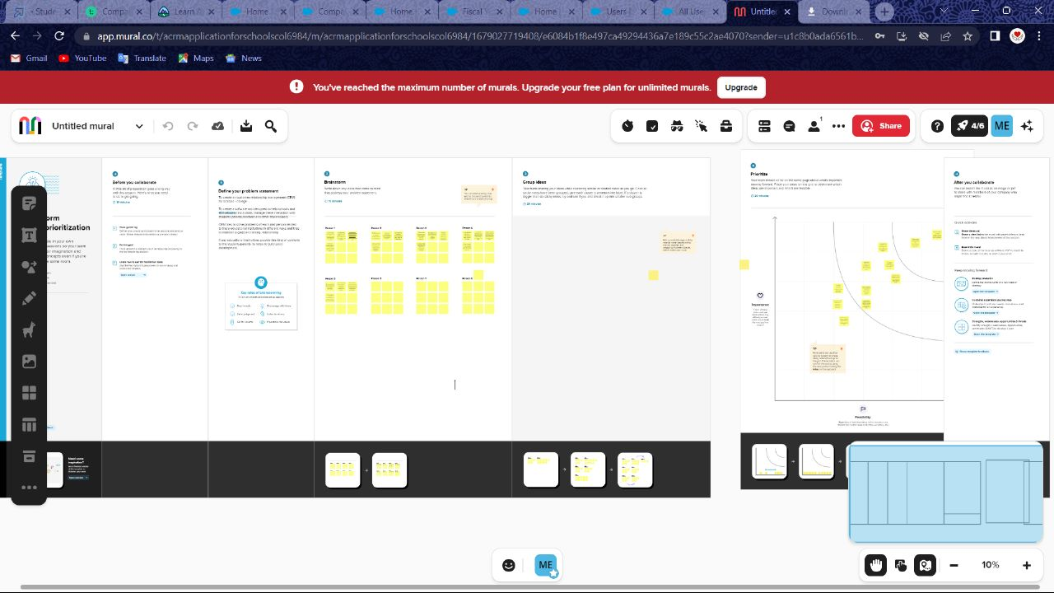

1. **RESULT**

3.1 Data Model:

|  |  |
| --- | --- |
| **Object name** | **Fields in the Object** |
| **School** | |  |  | | --- | --- | | **Field Label** | **Data Type** | | **Address** | **Text Area** | | **District** | **Text Area** | | **School** | **Text Area** | | **Phone Number** | **Phone** | | **Number of Students** | **Roll-up Summary** | | **Highest Marks** | **Roll-up Summary** | |
| **Student** | |  |  | | --- | --- | | **Field Label** | **Data Type** | | **Phone Number** | **Phone** | | **School** | **Master- Detail**  **Relationship** | | **Results** | **Picklist** | | **Class** | **Number** | | **Marks** | **Number** | |
| **Parent** | |  |  | | --- | --- | | **Field Label** | **Data Type** | | **Parent Address** | **Text Area** | | **Parent Number** | **Phone** | |

3.2 Activity & Screenshot

**Milestone-Object**

**Activity-1: Creation of School Object**

First we need to login to the salesforce. Now we need to create objects for school managements for schools ,students and parents .So now we are going to create object for schools.

First click on gear icon then click on setup and then click on the object manager then click on the dropdown symbol at the right and select custom object then fill the details of the label in single and plural way as school ,schools and object name as school and then scroll down and then check the Allow Reports checkbox and Check the Allow Search checkbox and then Click Save and then under Custom Object Tabs, click New and For Object, select School and For Tab Style, select any icon.Leave all defaults as is. Click Next, Next, and Save.

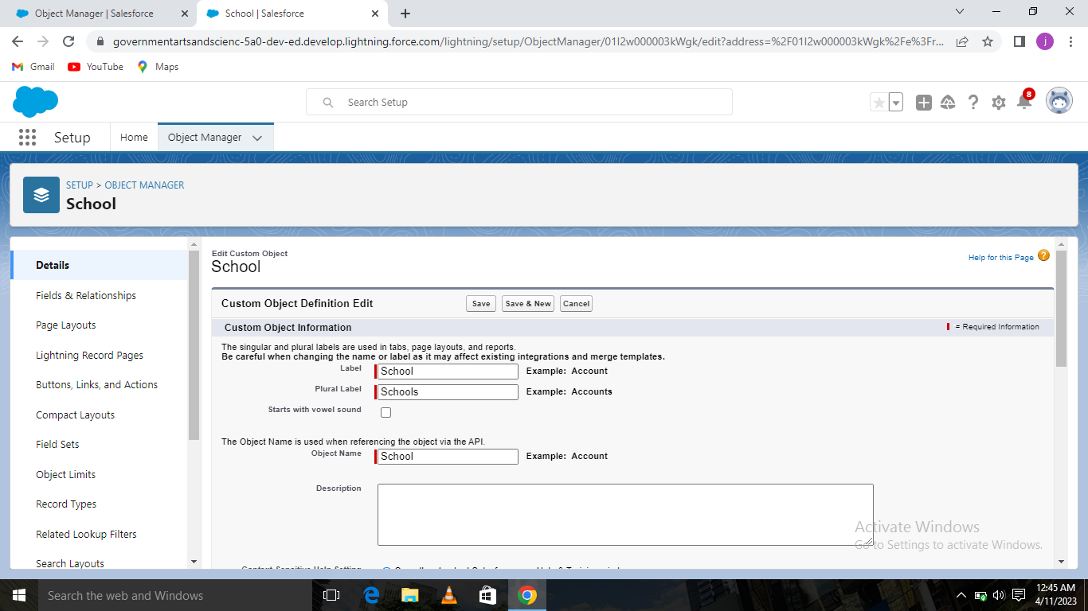

After saving you will get into the picture given below now the object for school has been made.

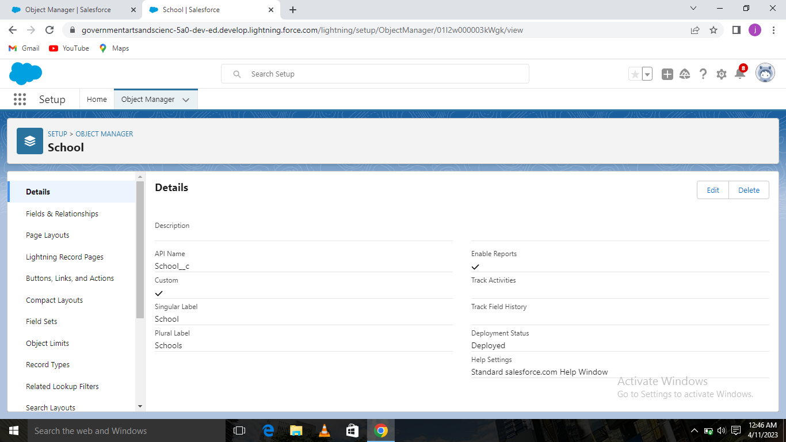

**Activity 2: Create student object**

As we did in the above schools object we follow the same steps and create students object here.

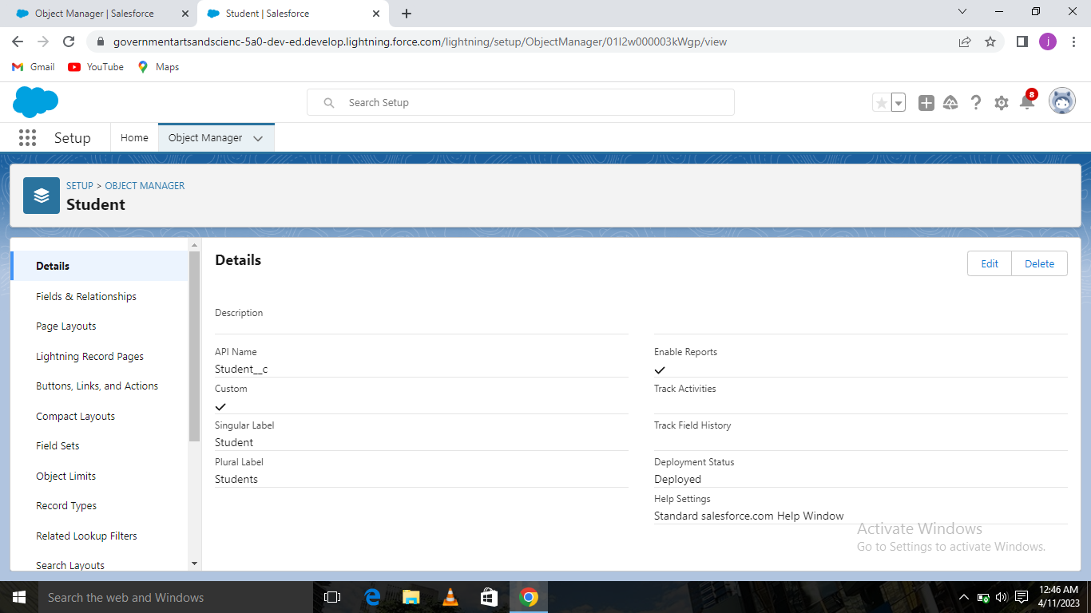

**Activity 3: Create parent object**

As we did in the above schools ,students object we follow and obtain object for parents here.

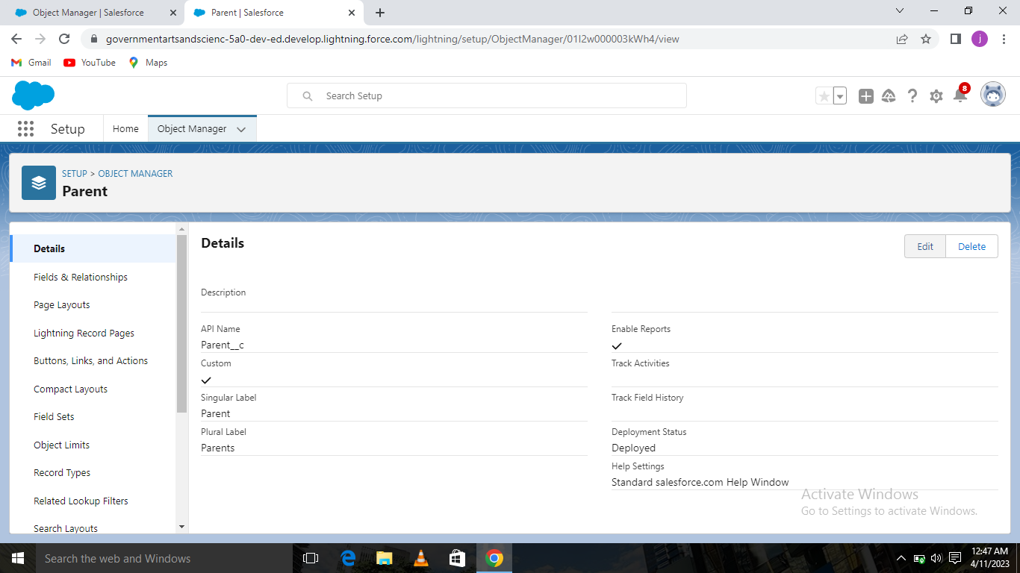

**Milestone-Lightning App**

**Activity:** **Create the School Management app**

From Setup, enter App Manager in the Quick Find and select App Manager. Click New Lightning App. Enter School Management as the App Name, then click Next.

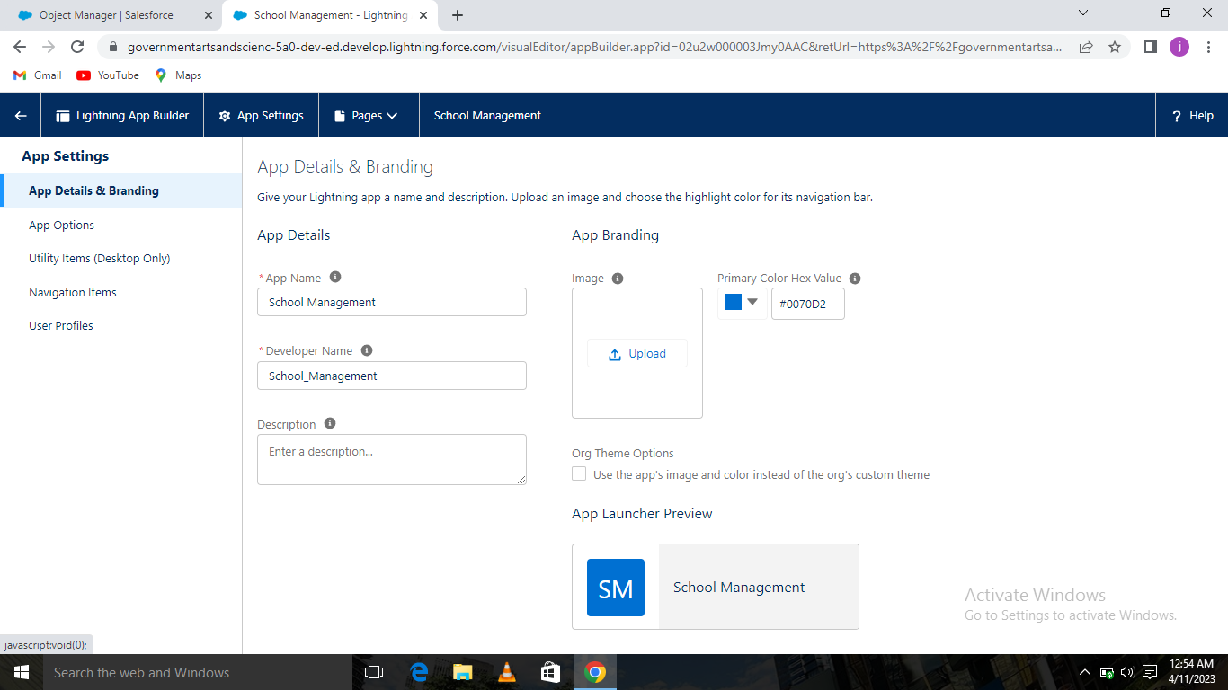

Under App Options, leave the default selections and click Next.

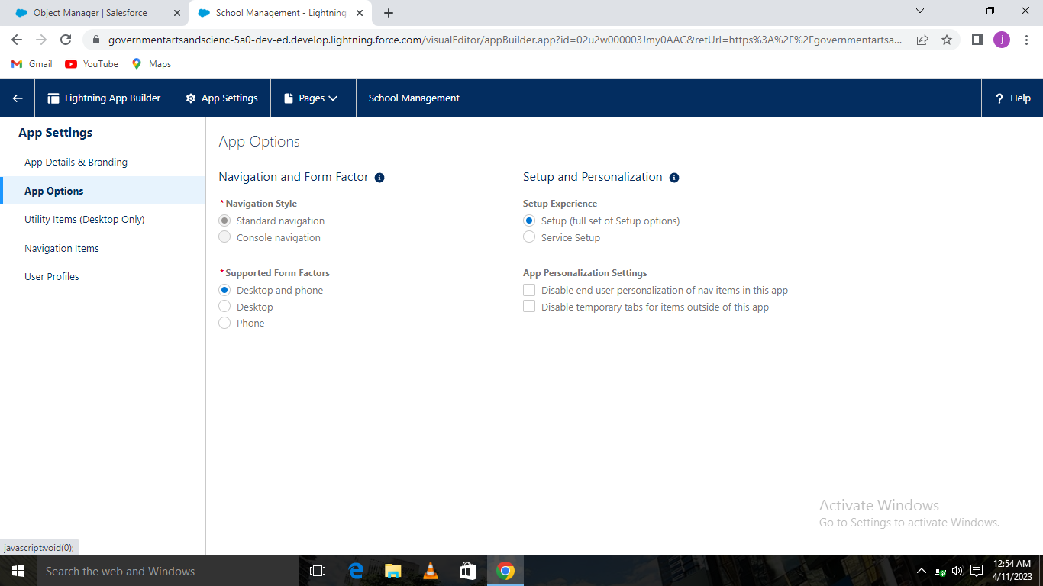

Under Utility Items, leave as is and click Next.

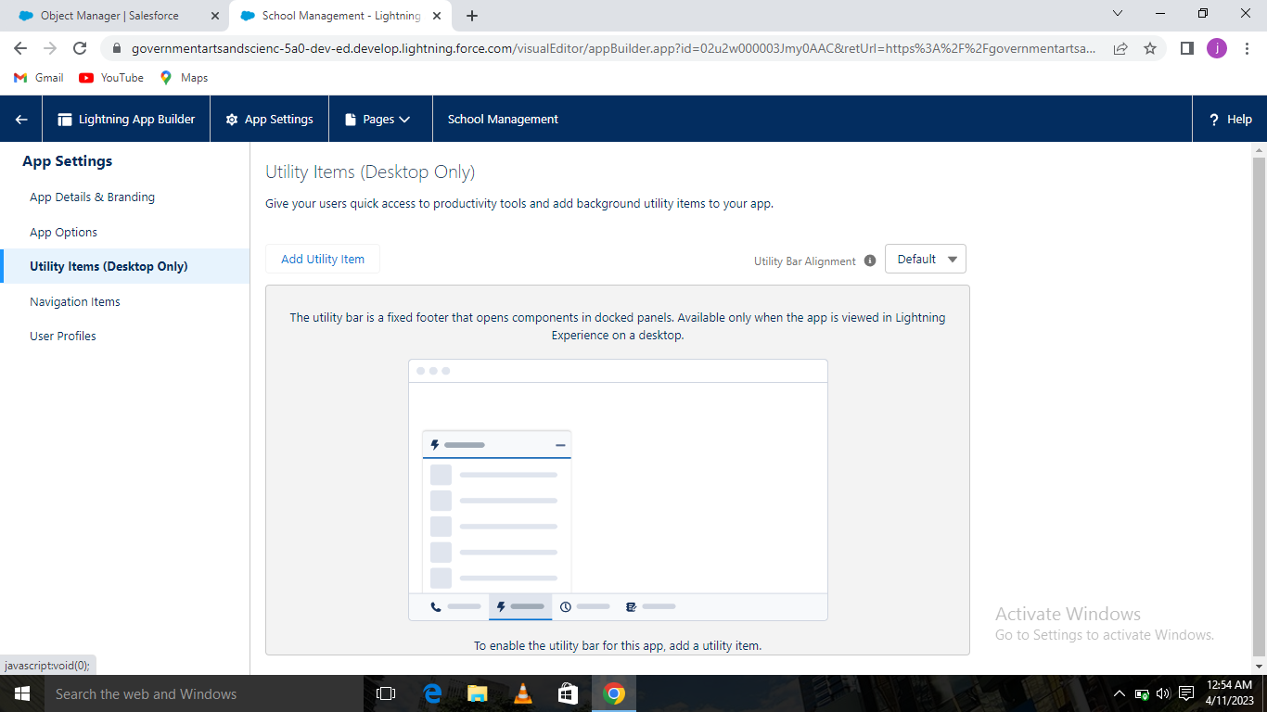

From Available Items, select Schools ,Students ,Parents, Reports, and Dashboards and move them to Selected Items. Click Next.

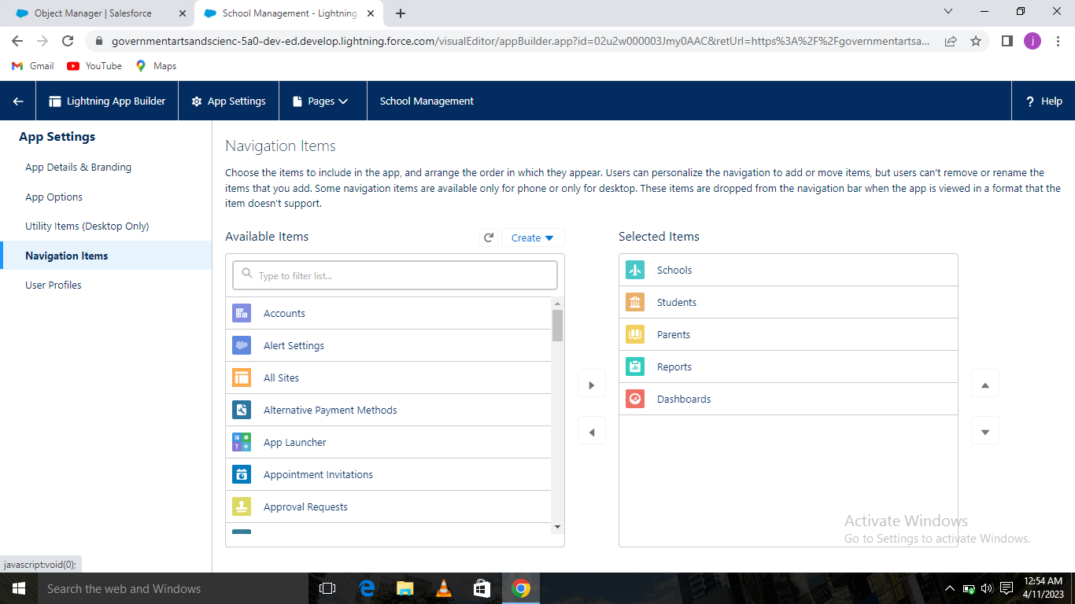

From Available Profiles, select System Administrator and move it to Selected Profiles.

Click Save & Finish. To verify your changes, click the App Launcher, type School Management and select the School Management app. The School Management has been prepared.

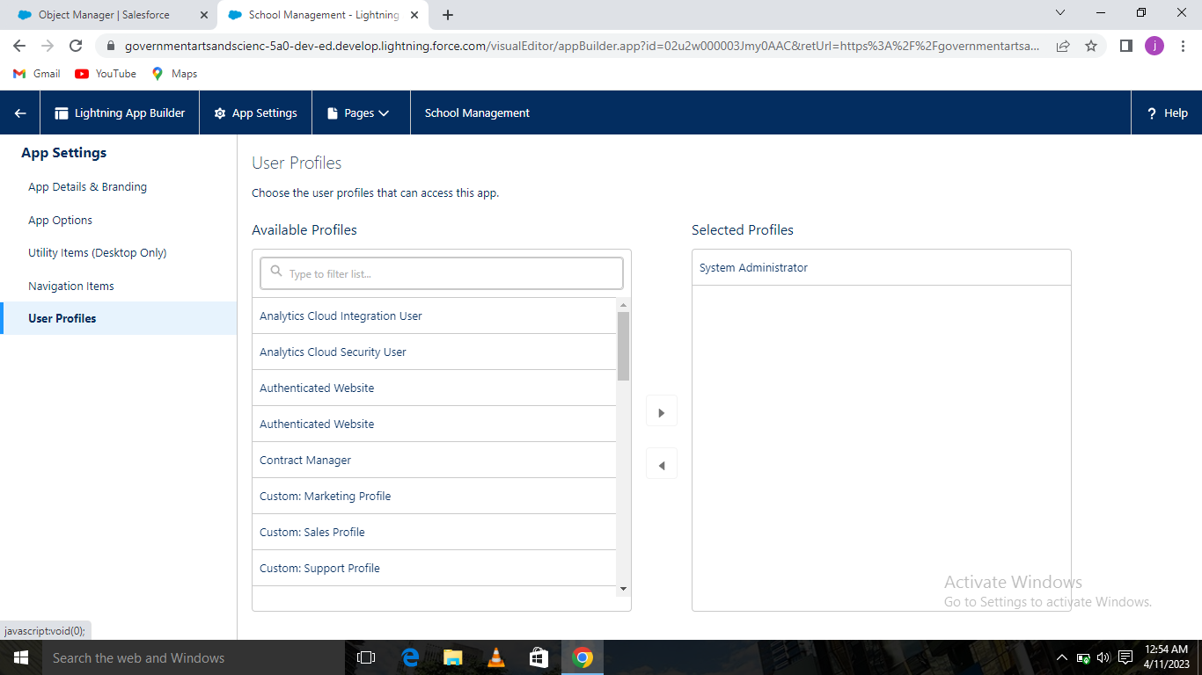

**Milestone -Fields and Relationship**

**Activity-1: Creation of fields for the School objects:**

Click on the school object. Select Fields & Relationships from the left navigation, and click New. Select the Text Area as the Data Type, then click Next .For Field Label, enter Address .Click Next, Next, then Save & New.

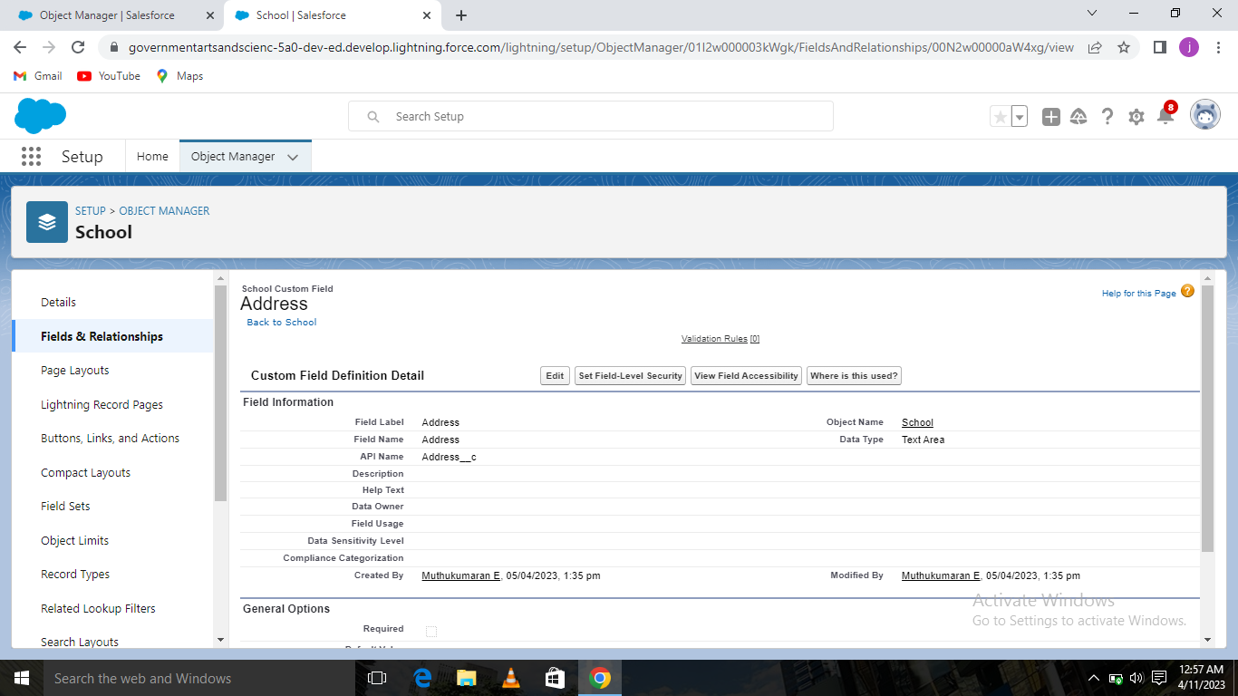

We create two more text areas with District ,State and School websites as the field labels as we have done above.

District :

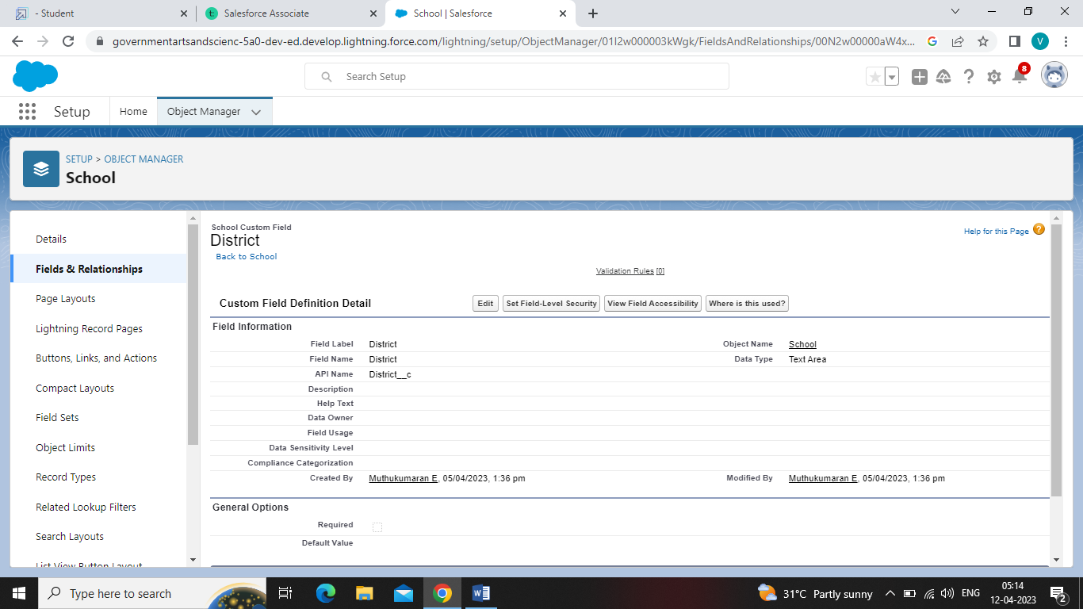

State:

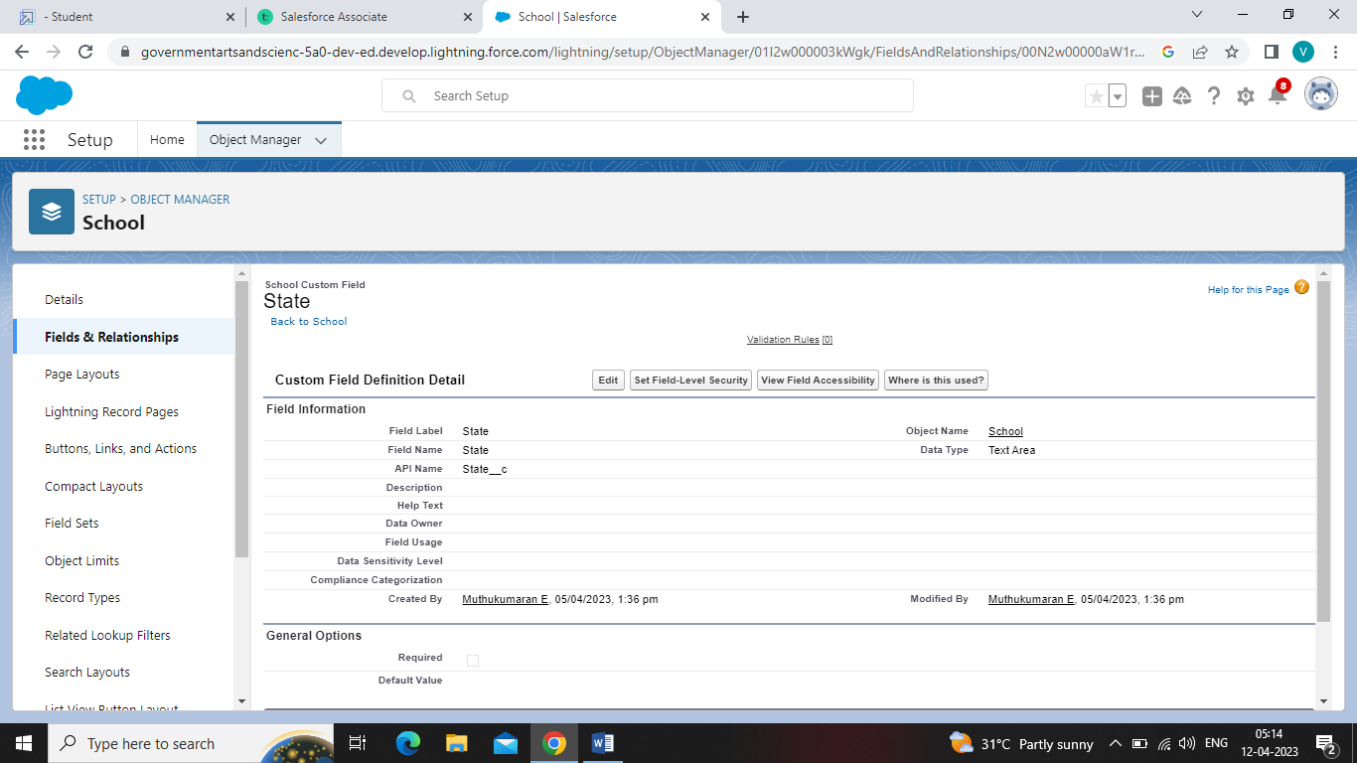

School Websites:

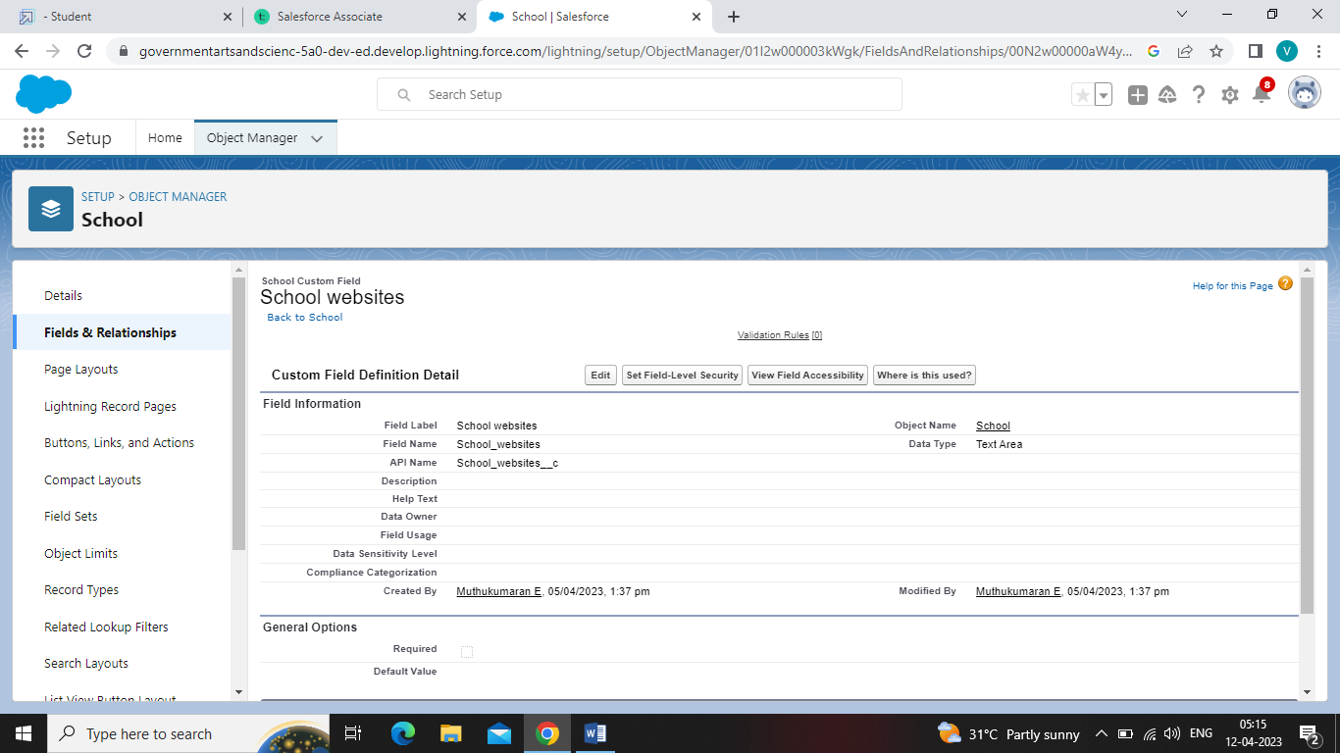

**Activity-2:** **Creation of fields for the Student objects:**

Select the Phone as the Data Type, then click Next .For Field Label, enter Phone Number .Click Next, Next, then Save & New.Let's create a master-detail relationship with school object.Select Master-Detail Relationship as the Data Type and click Next.For Related to, enter School.Click Next.For Field Label, enter School.Click Next, Next, Next and Save.Select Picklist as the Data Type and click Next.For Field Label enter Results.Select Enter values, with each value separated by a new line and enter these values:Pass,Fail.Click Next, Next, then Save & New Lets create a Number field.Select the Number as the Data Type, then click Next.For Field Label, enter Class.Click Next, Next, then Save & New.

School :

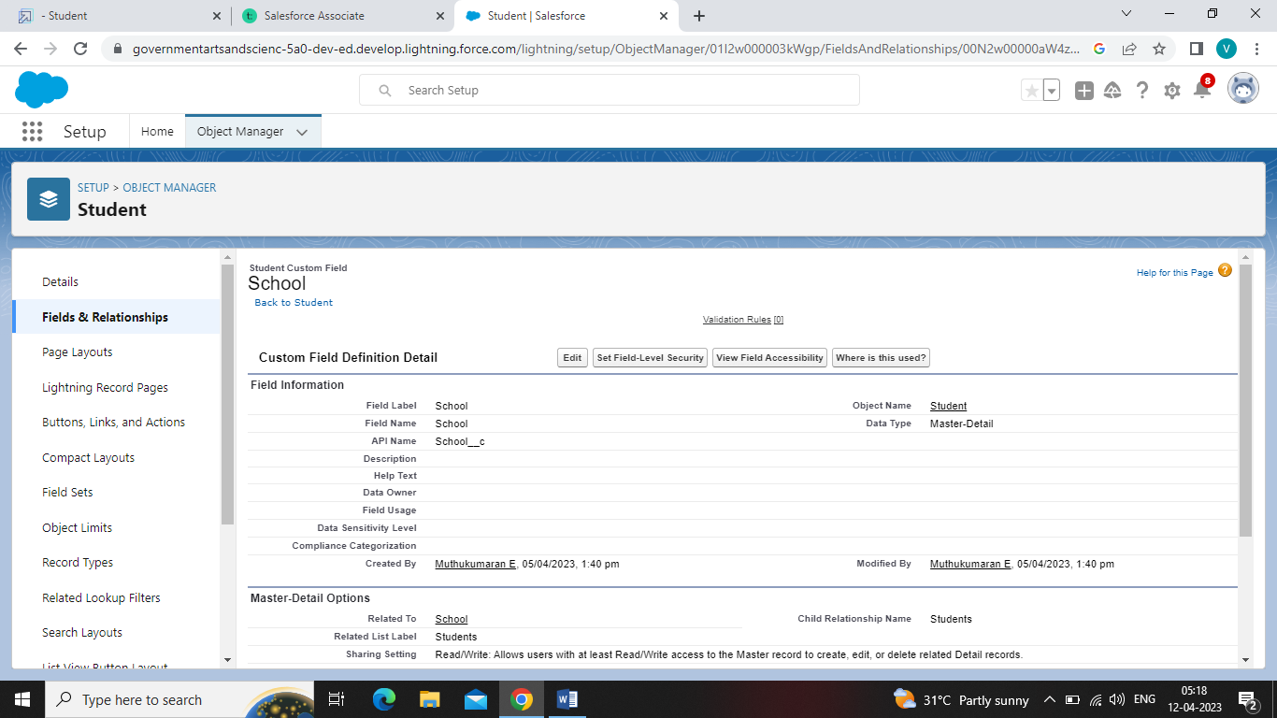

Phone Number :

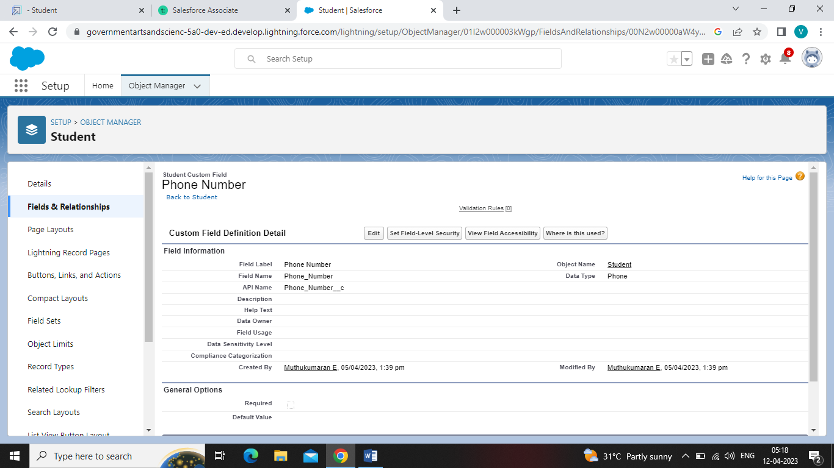

Results :

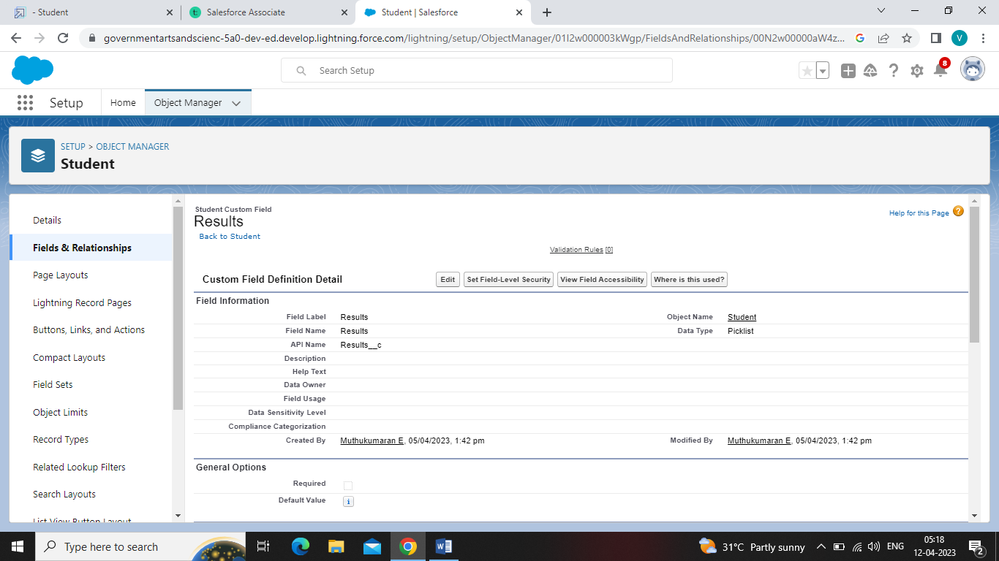

By following steps 1 through 3 and create one more number field with Marks as the field labels.

Marks :

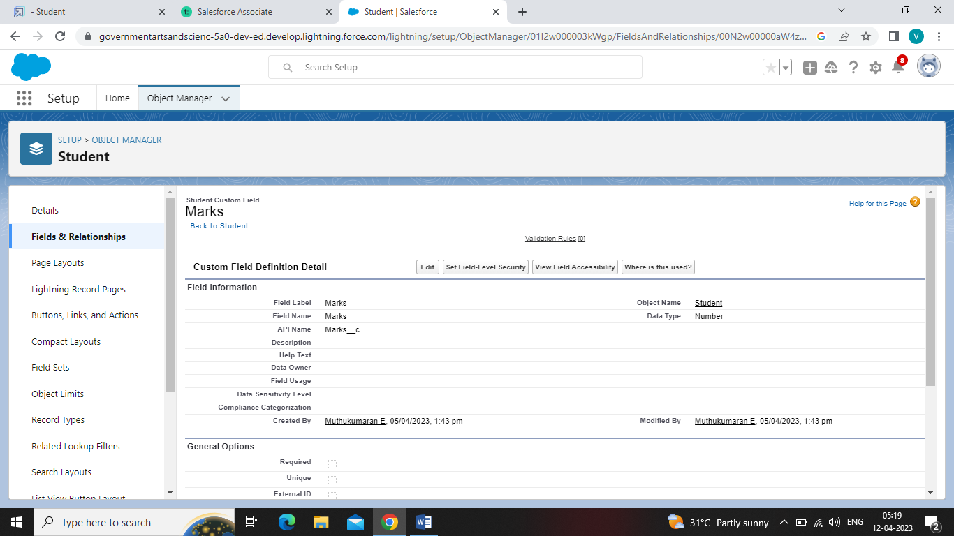

**Activity-3:** **Creation of fields for the Parent objects:**

Select the Text Area as the Data Type, then click Next .For Field Label, enter Parent Address .Click Next, Next, then Save & New .Select the Phone as the Data Type, then click Next. For Field Label, enter Parent Number .Click Next, Next, then Save & New.

Parent Address :

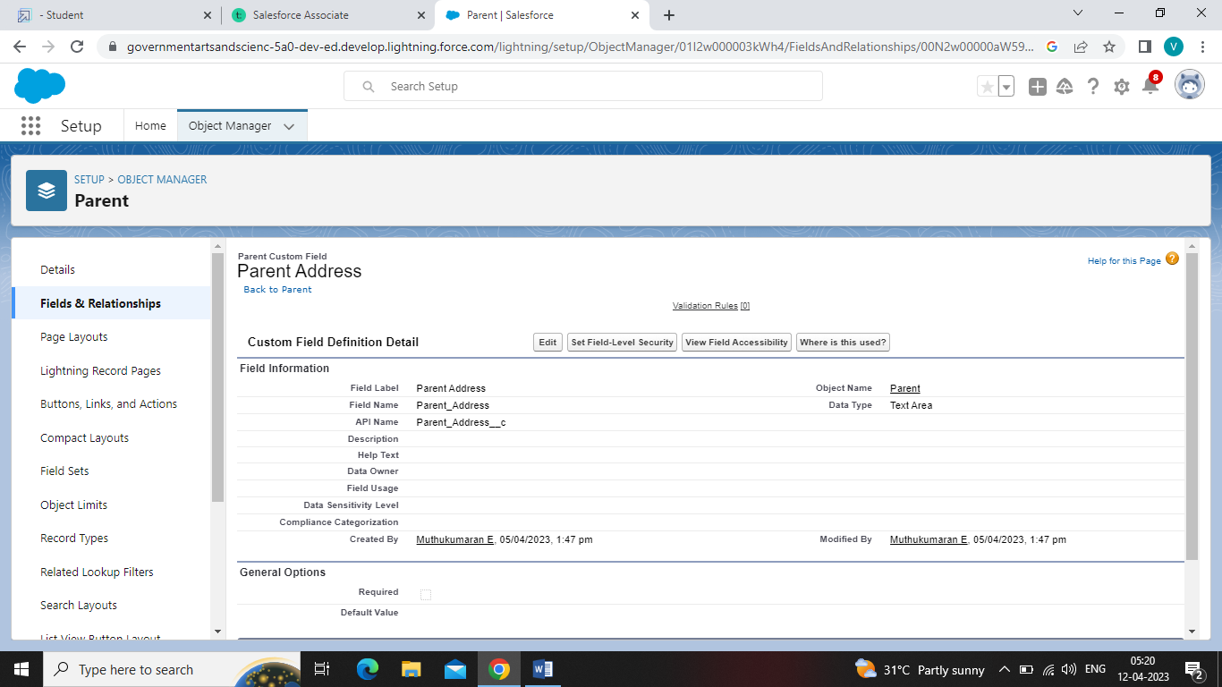

Parent Number :

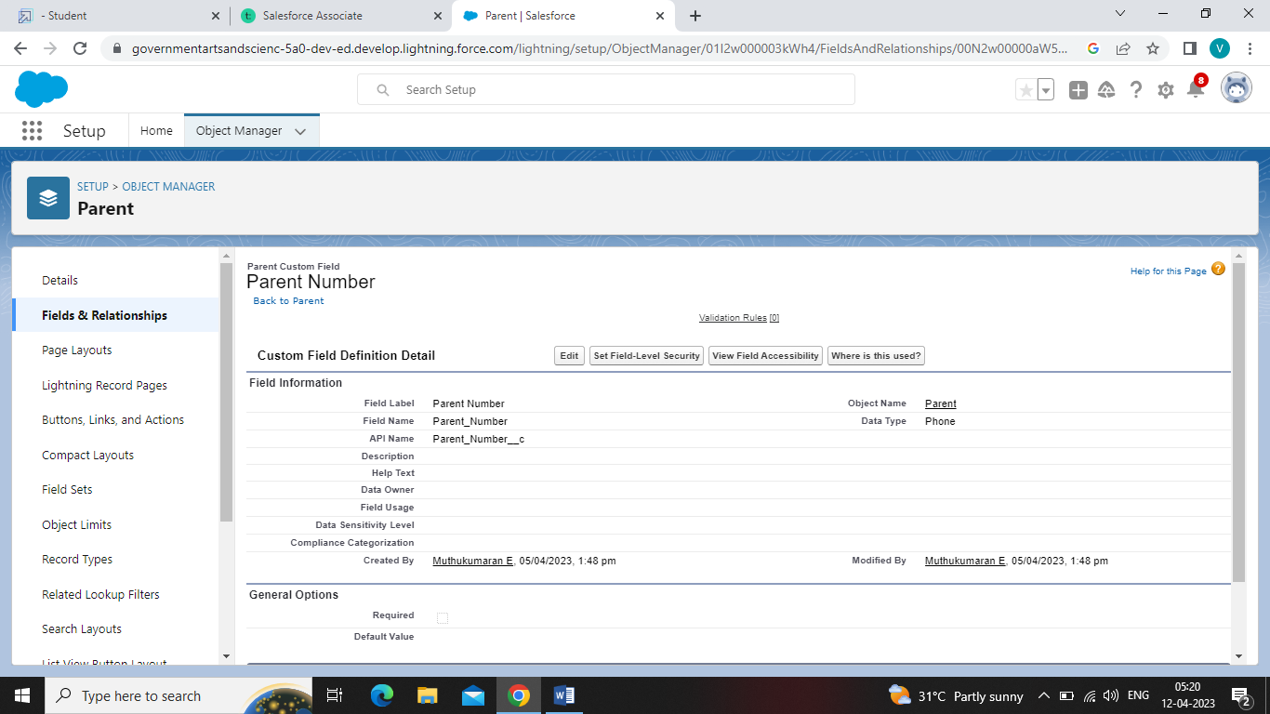

**Milestone- Profile**

**Activity:** **Creation on profile**

Setup enter Profiles in the Quick Find box, and select Profiles.From the list of profiles, find Standard User.Click Clone. For Profile Name, enter School profile. Click **Save.**

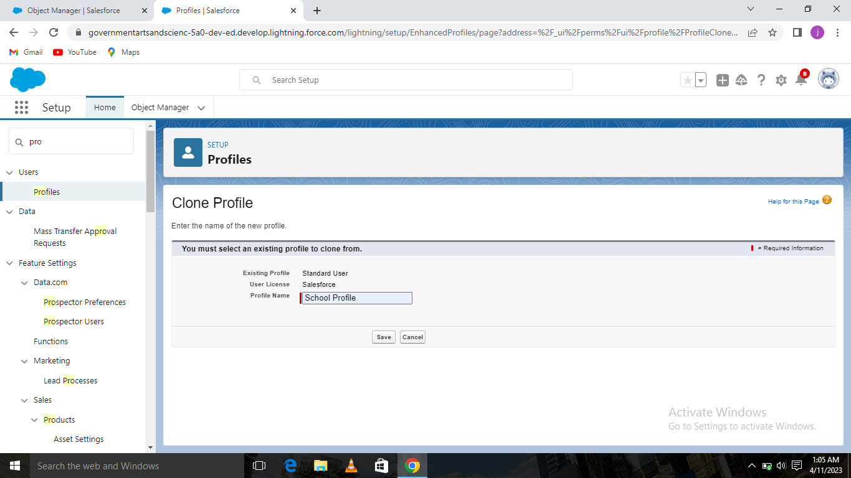

While still on the School profile page, then click **Edit**.Scroll down to Custom Object Permissions and Give view all access permissions and assign to the parent profile.

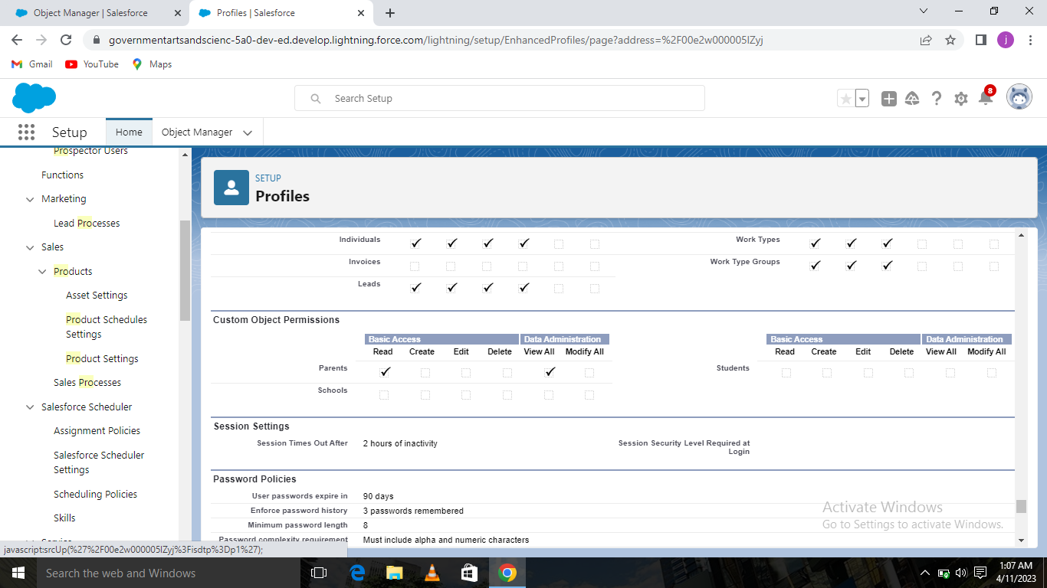

**Milestone- Users**

**Activity :** **Creating a Users:**

From Setup, in the Quick Find box, enter Users, and then select Users .Click New User**.**

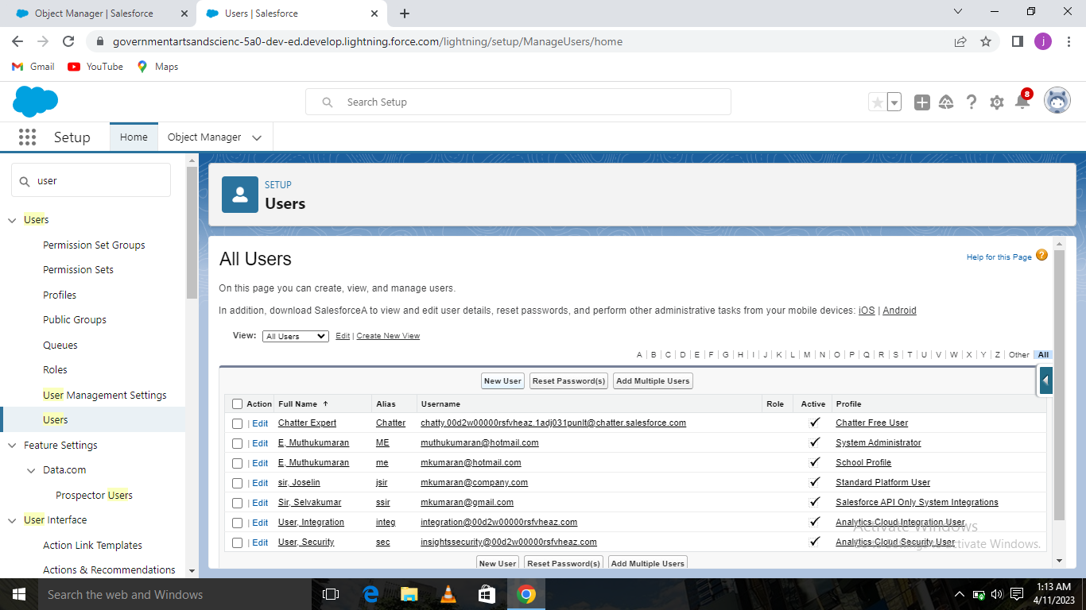Enter the user’s name Parents and (Your) email address and a unique username in the form of an email address. By default, the username is the same as the email address.Select a User License As salesforce.Select a profile as a School profile.Check Generate new password and notify the user immediately to have the user’s login name and a temporary password emailed to your email.

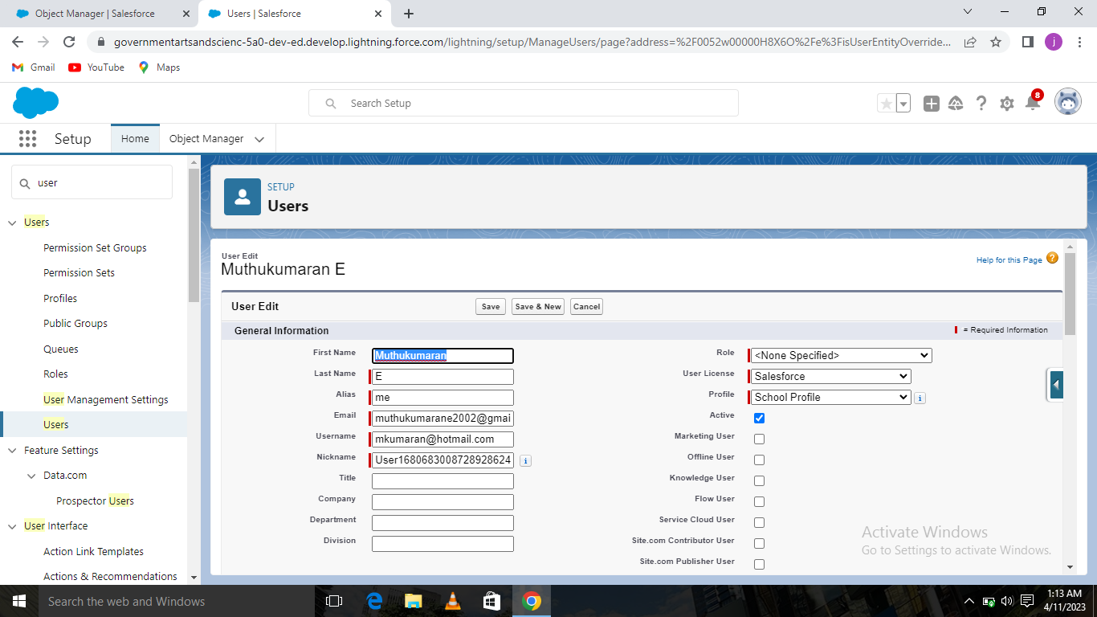

Similarly follow the above steps and create users as Teachers.

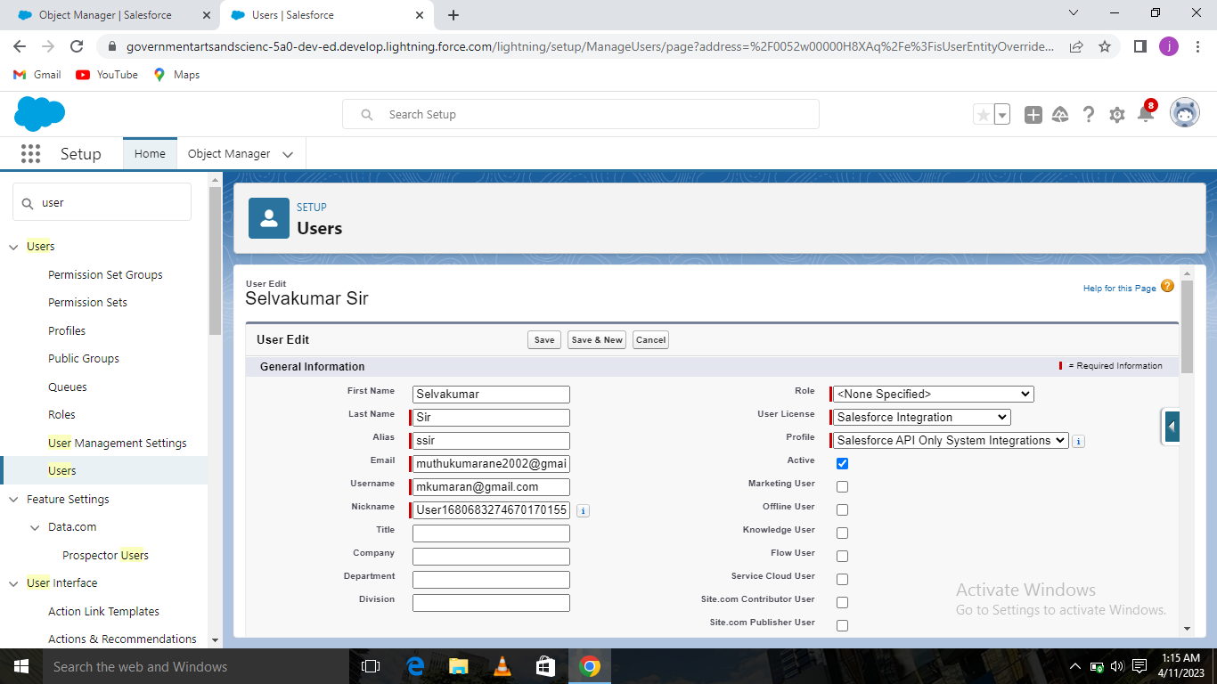

Similarly follow the above steps and create users as Principal.

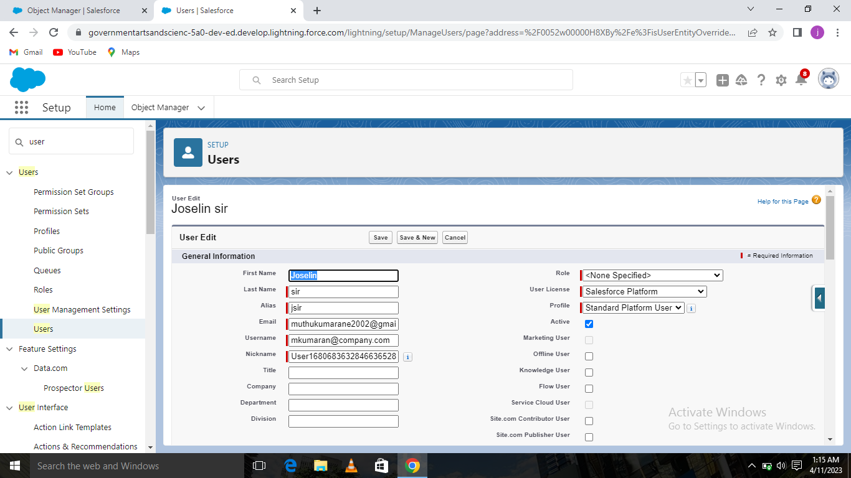

**Milestone-Permission sets**

**Activity-1:** **Permission sets 1**

From Setup, enter Permission Sets in the Quick Find box, then select Permission Sets .Click New. Give the name of the Permission set name as teacher permission and then under the object settings give the view create and edit permissions to all custom objects and assign to the teacher user.

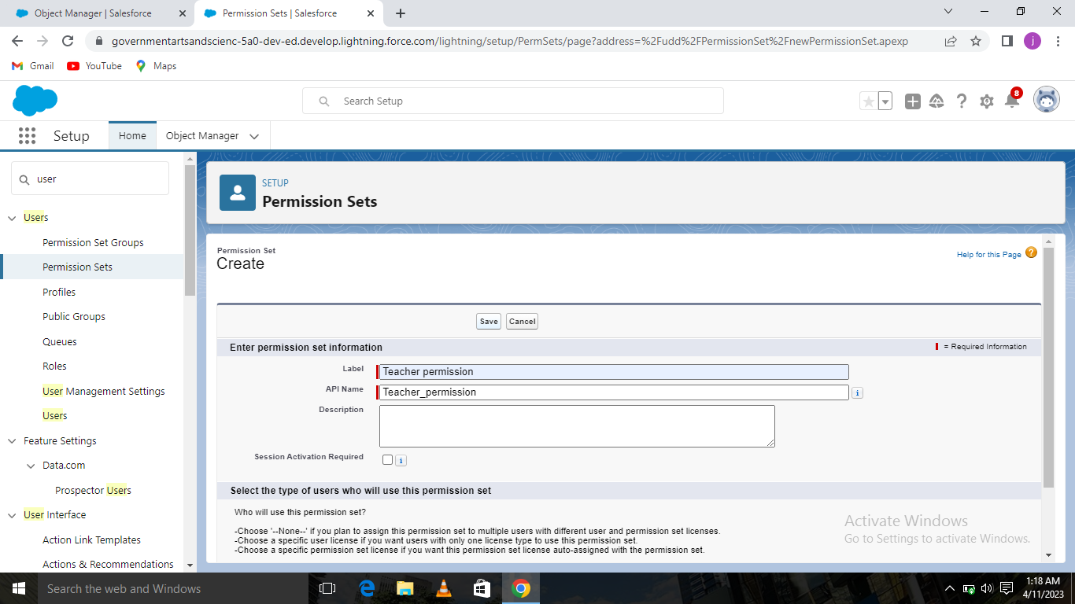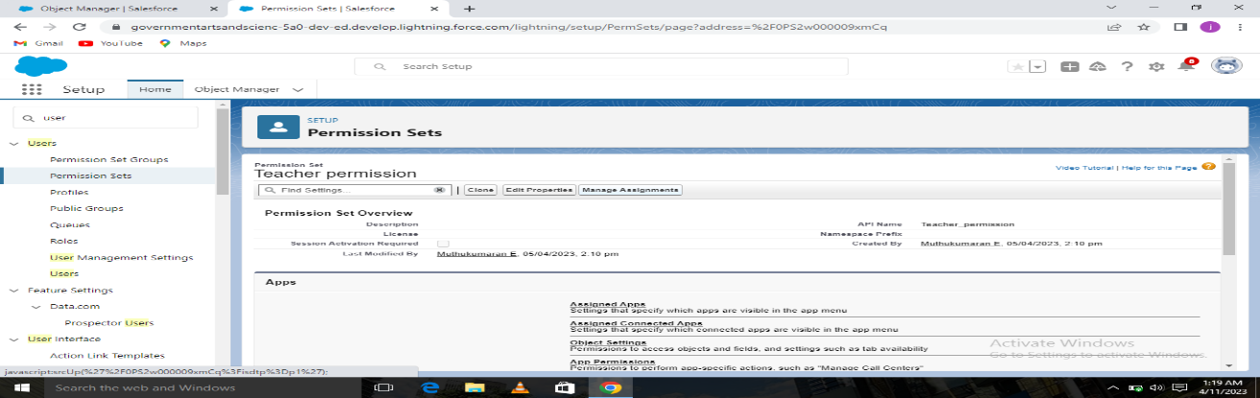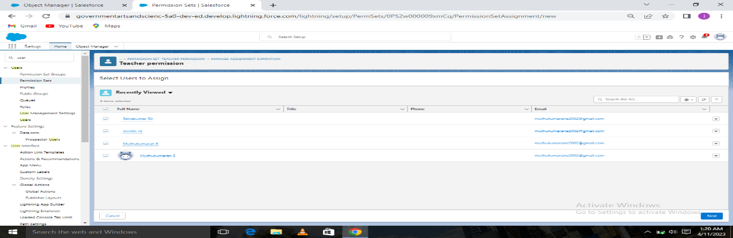

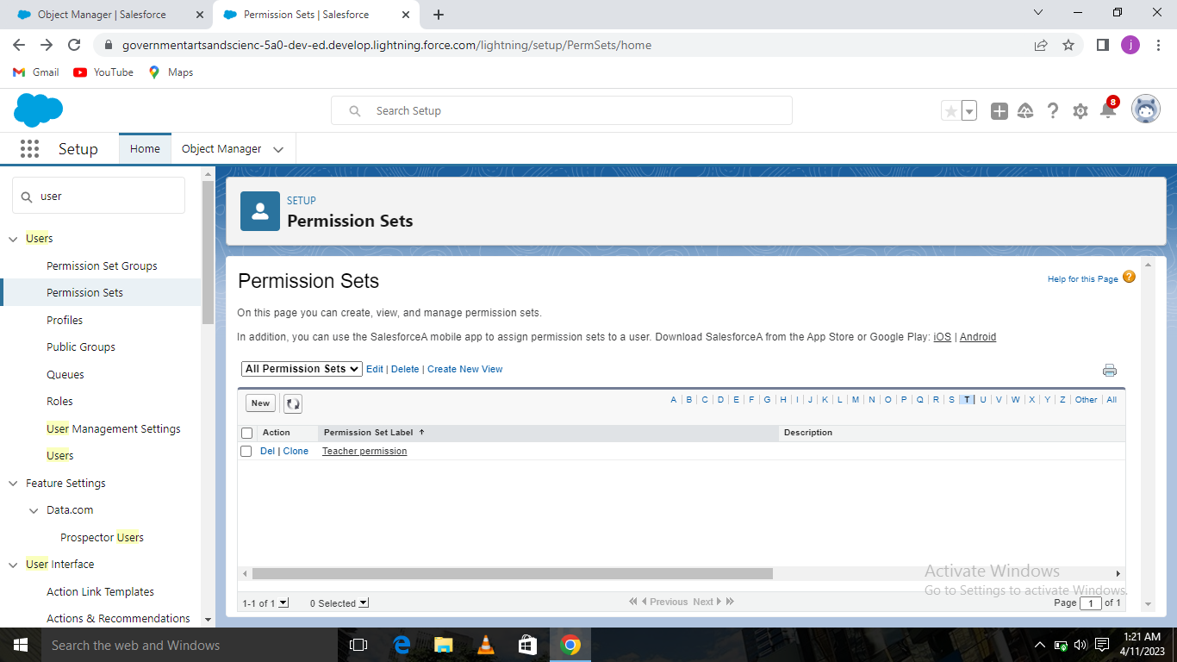

**Activity-2:** **Permission sets 2**

From Setup, enter Permission Sets in the Quick Find box, then select Permission Sets.Click New.

Give the name of the Permission set name as Principal permission and then under the object settings give all permissions for the custom objects and assign them to the Principal user.

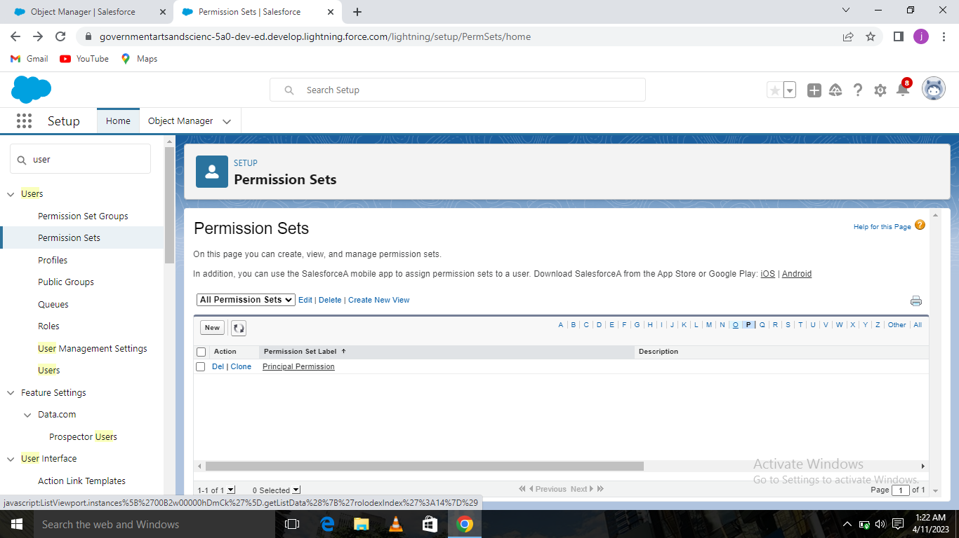

**Milestone-Reports**

**Activity- Reports :**

From the Reports tab, click New Report.Select the report type as School with students and parents for the report, and click Create.Customize your report, then save or run it.

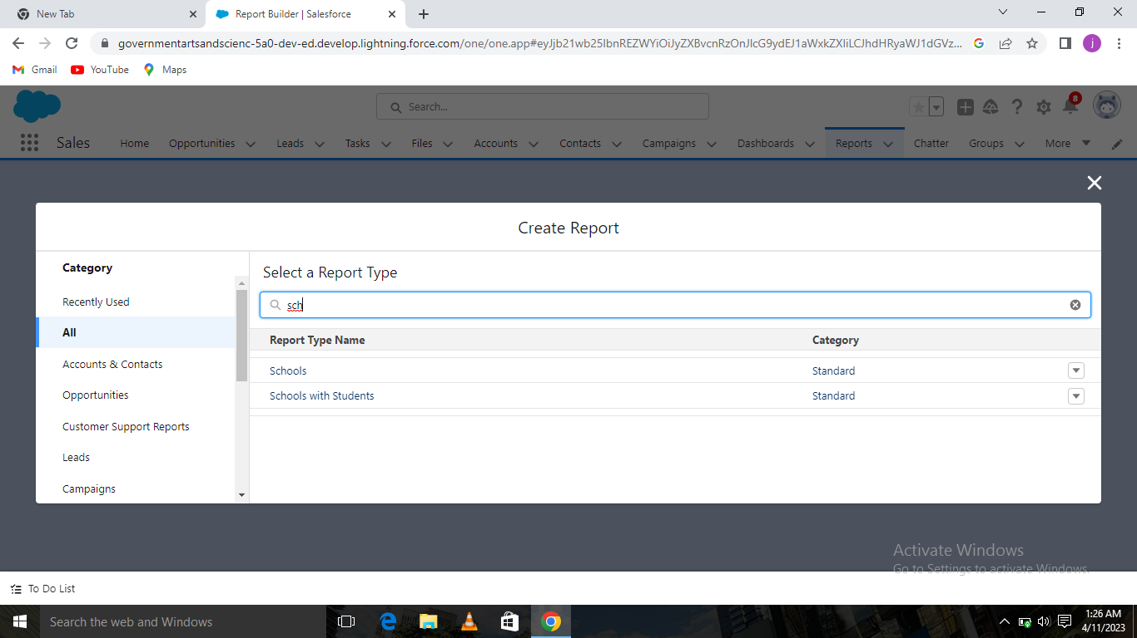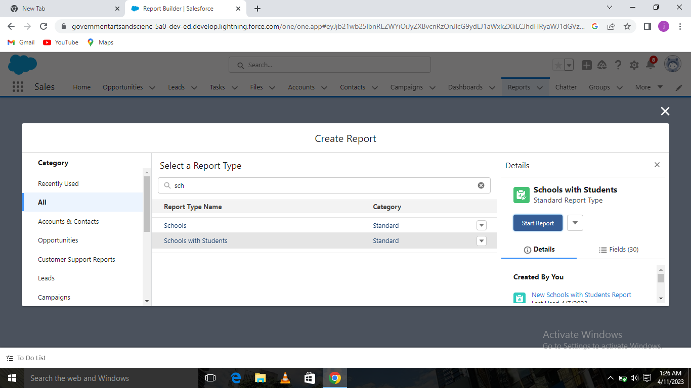

After creating now we enter the datas in students,parents,school and create report using the new New schools with students report and New Parent Report and the dashboards are also made.

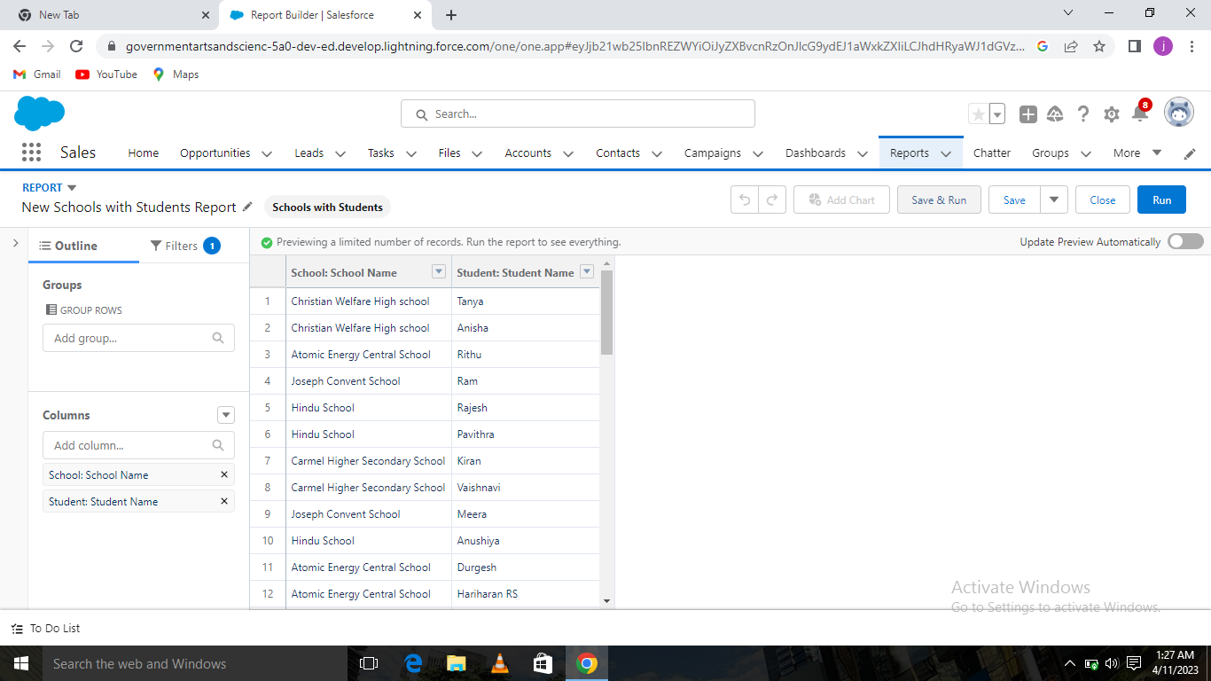

New Schools with Students Report :

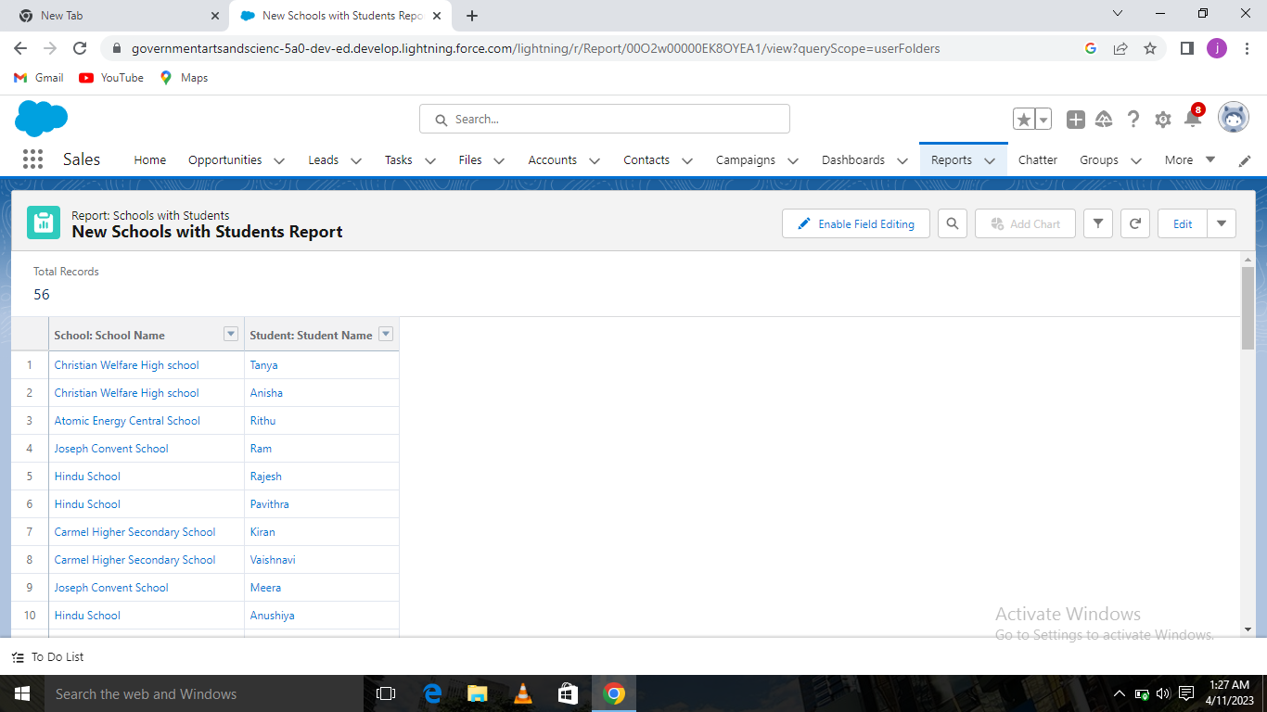

New Parents Report **:**

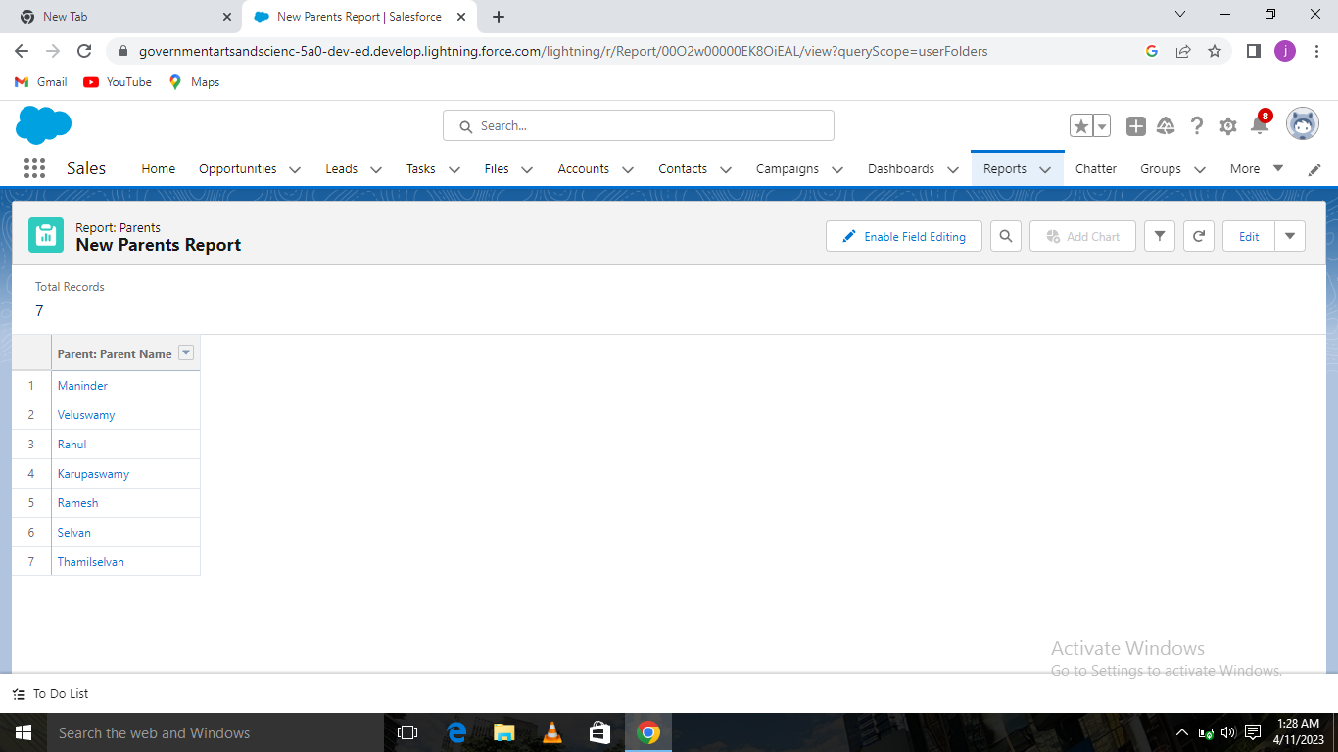

**Dashboard and results obtained .**

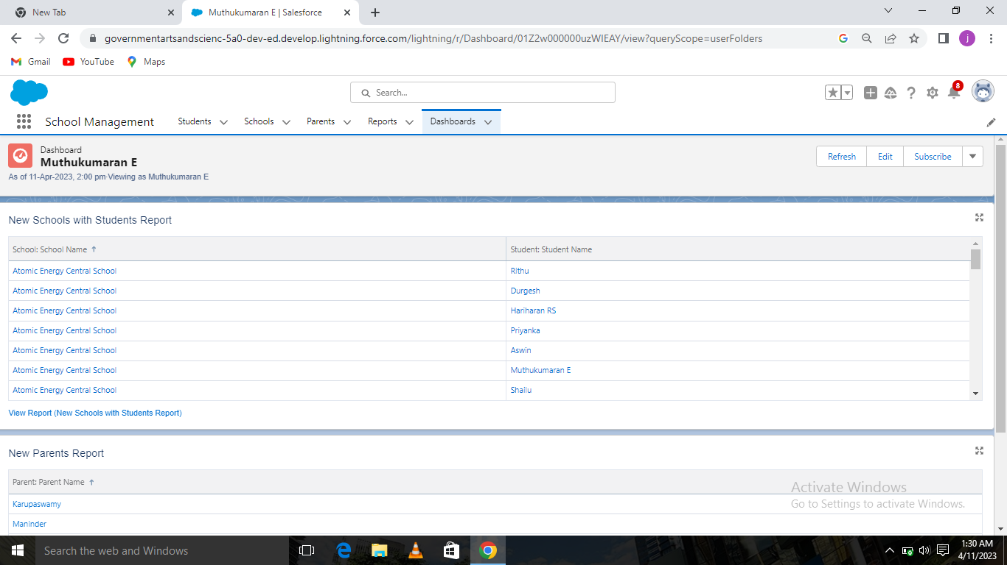

1. **Trailhead Profile Public URL**

**Team Lead –** <https://trailblazer.me/id/muthe3>

**Team Member 1 –**  <https://trailblazer.me/id/esakm3>

**Team Member 2-** <https://trailblazer.me/id/mathm26>

**Team Member 3-** <https://trailblazer.me/id/mathm25>

**Team Member 4 -** <https://trailblazer.me/id/jjoselin1>

1. **ADVANTAGES & DISADVANTAGES**

Advantages **:-**

* It is very easy for handling as it is build in easy understandable and access manner .
* It helps teachers to focus on there primary activity of proving high quality education.
* It will bring on everyone together and create a good relationship.
* It will be very easier for everyone to access the needed information at any place.
* It is so safe and secured to use.
* It will reduce time consumptions.

Disadvantages:-

* Everyone won’t have more awareness and know about the features in mobile as for example parents who are uneducated.
* There can be chances of misprint of marks or wrong marks by chance.
* There is always a fear of personal details being secured or not.
* There should maximum care while entering the details small change in the personal details can created more problematic of childrens future.
* It might look somewhat costlier.

1. **APPLICATIONS**

* School
* College
* Educational Institutions
* Labs
* Library
* Hospitals
* Medical Research Sectors

1. **CONCLUSION**

This application was very informative .This application is giving us all the detailed account of schools ,students and parents . This application helps to the betterment of the individuals performance in academics.This application is very simple and secured and well designed. It should be widely used in every fields.

1. **FUTURE SCOPE**

In Future , it will be made compulsory as for every schools to have and work on customer relationship management . It will provide more additional and standard feature as of every activity of the individuals performance in various fields and being listed and tracked .Update of the students medical reports are being are also be noted and tracked on. It will be widely applicable in every fields.